Problem statement :
Categorize specific customer needs into higher level needs.

2.contractibily
5.Adjustable size of the platform
4.Adjustable angle
3.Range of height
6.
7.

Product design

5.Flexible solar cells
4.Integrated LED indicators
3.Adjustable angle and position
2.Simple setup
1. Solar tracking
6.Enclosure included
7.Integrated battery storage

2.Durable carrying case
1.Portable and contractility
Durability/ Using conditions
3. Wear and tear resistance

4. Less setting time

Social & economics

1.Less maintenance cost
2.Low cost
4. Less repair cost
3. Eco friendly and recyclable materials

Composition and finish

1.Quality
2.Coated surface
5.Eco friendly and low cost material
4.Handy looking and beautiful.
3.Light weight
6.Small space utilization

Performance

1. High energy efficiency
2. Fast charging
4.High capacity with in build battery systems
3.Multiple device prot compatibility

Additional features

1. Expandable additional panels
2.Self cleaning surfaces
5.Automatic transmission
4.Product with different colours.
3. Multifunctional usage
6.Handle easily.
8. Shockproof
9. Compact folding mechanisms

AHP catalog
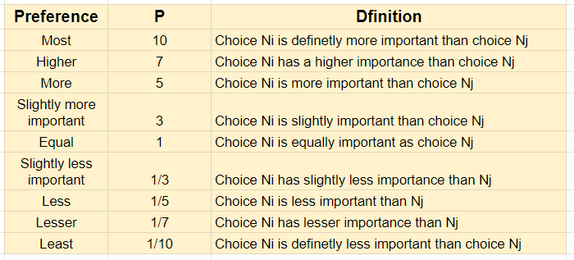

AHP Matrix

 | Product Design | Durability/ Using conditions | Social & economics | Performance | Additional features | Composition & finish | Row Total | Relative importance | Scaled importance | Rounded scaled importance
Product Design | 1 | 5 | 7 | 3 | 10 | 7 | 33 | 39.83% | 10 | 10
Durability/ Using conditions | 1/5 | 1 | 3 | 1/3 | 5 | 1 | 10.533 | 13.1% | 3.3484 | 3
Social & economics | 1/7 | 1/3 | 1 | 1/7 | 3 | 1/3 | 4.9524 | 6% | 1.696 | 2
Performance | 1/3 | 3 | 1/7 | 1 | 10 | 7 | 21.4762 | 25.92% | 6.5885 | 7
Additional features | 1/10 | 1/5 | 1 | 1/10 | 1 | 1/5 | 2.6 | 3.14% | 1 | 1
Composition & finish | 1/7 | 1 | 3 | 1/7 | 5 | 1 | 10.286 | 12.42% | 3.27528 | 3

